TAIWAN'S KEY ECONOMIC DEPENDENCIES: THE CHINESE AND THE U.S. RELATIONS
STOCK MARKET CORRELATION ANALYSIS AND EVENT ANALYSIS
Supervisor: Dr. Majoros, Pál
DISSERTATION
Thesis Booklet

Doctoral School in Management Sciences and Business Administration
University of Pannonia
Veszprém
2023

Szentesi, Ambrus Gábor

Table of Contents

1. Introduction 2
1.1. The Topic 2
1.2. Research Concept 3
1.3. Research Questions and Hypotheses 4
2. Correlation Analysis on the Stock Markets 4
2.1. Introduction to the Methodology 5
2.2. The Specification of the Correlation Analysis 5
2.3. Results 7
2.3.1. Mainland Chinese Stock Exchanges 7
2.3.2. The Special Role of Hong Kong 8
3. Event Study Analysis 10
3.1. General Introduction 10
3.2. The Specification of the Analysis 11
3.2.1. Data Collection, Data Preparation 11
3.2.2. Model Specification, Model Versions 11
3.3. Results 12
3.3.1. Benchmark Model Versions 12
3.3.2. The Impact of Collected Taiwanese, Chinese, and American News 14
4. Conclusion 18
4.1. First Hypothesis 18
4.2. Second Hypothesis 19
4.3. Third Hypothesis 19
4.4. Fourth Hypothesis 21
5. Reference List 22
6. List of Related Publications 23

Introduction

The Topic
Taiwan occupies a unique place in the world from a historical, economic, and political perspective. The so-called Taiwan issue is undeniably the most sensitive point for China, as due to the unresolved Chinese civil war, Taiwan has become the focal point of the most significant legitimacy problem for the Chinese Communist Party (CCP). During the Cold War, Taiwan, under the dictatorship of the KMT as well as within the protective alliance system of the United States, first flourished as a capitalist economy and then, from the 1980s onwards, evolved into a vibrant democracy. Its economic rise, as with the other East Asian ’Tigers', was crucially influenced by the United States and, from the 1990s onwards, increasingly by China. More precisely, for a long time, Taiwan played a critical role first in the Chinese economic boom (Kastner, 2009) – primarily through the so-called taishang.
In recent decades, the Taiwanese and Chinese economies have become closely intertwined. According to estimates, the cumulative size of Taiwanese operating capital in China is in the hundreds of billions of dollars (Ministry of Foreign Affairs, 2019). Largely thanks to the governance under Ma Ying-jeou (2008-2016), a number of bilateral agreements of varying significance gradually liberalized trade between Taiwan and China – the most important being the Economic Cooperation Framework Agreement signed in 2010 (Mainland Affairs Council, 2019). Since 2004, Taiwan's exports to China have been the most valuable – surpassing those to the United States for the first time. In 2021, the ratio was 30% to 15% in favor of China in terms of Taiwanese exports (Nature, 2022). The initial relationship has thus thoroughly reversed, and for decades now, the issue of economic dependence on China and its mitigation has been a constant topic in Taiwan.
Taiwan’s situation is however, very complex. While the Chinese Communist Party continues its policy of 'reunification' with Taiwan by all possible means, Taiwan has become a vibrant democratic society with a globally significant and strong economy. It remains an extremely important element of the United States' East Asian alliance system. One of the key reasons for this is that Taiwan has become an indispensable player in the production of critical semiconductors for the modern tech industries on a global scale. In the past decade, especially with the trade war initiated by Donald Trump – which the Biden administration continues, albeit with a different approach – the economic and political dimensions are increasingly merging near the shores of Taiwan. The great power tension between the United States and China over Taiwan makes the island a focal point in global politics and economics, putting it in a prominent, yet perilous position.
The examination of Taiwan's fate is simultaneously an examination of the greatest power rivalry of our time. Since the 2010s, it has become a general opinion that due to the depth of the integration of the Taiwanese and Chinese economies, Taiwan's economy is primarily exposed to China. However, this is not so clear-cut, as a significant portion of Taiwanese-origin investments in China and the increased bilateral trade are largely aimed at more efficiently serving American – and other Western – markets. Taiwan seems to be caught between the two superpowers, but which one does it depend on more in economic terms? Does it rely more on China economically or still on the United States? If on China, since when? When did the shift occur? How can this dependency/reliance be captured? Which side will Taiwan take if the so-called American-Chinese 'decoupling', or economic separation, actually occurs? The aim of this dissertation is not an extensive discussion of Taiwan's role in global politics or economics, nor is it to take a stance on the relevant issues. With my research, I attempt to uncover, to a certain extent, Taiwan's economic vulnerability towards both the United States and China, as well as the change in this two-way exposure over the span of more than three decades from 1991 to 2023.

Research Concept
Vulnerability exists for every open and relatively small economy. The Taiwanese economy is fundamentally export-oriented, with its largest trading partner being China, and its unresolved political status also tied to China. It might seem logical that the Taiwanese economy is most vulnerable to the Chinese economy. However, this picture is nuanced by the fact that the biggest and most integrated Taiwanese companies into Global Value Chains (GVCs) still primarily serve the markets of the USA and the EU. This exposure, however, only appears in the export numbers on China's side due to the relocation of production units in the past two to three decades. Thus, a significant portion of Taiwan's economic output still depends on Western markets through Chinese intermediation – as is largely true for the Chinese economy itself.
The openness of national economies is typically measured by their foreign trade volume relative to GDP. However, to answer whether Taiwan is more dependent on the Chinese or the American economy – or more accurately, which one it is more exposed to – we cannot simply calculate the Taiwanese/Chinese and Taiwanese/American trade exposure ratios relative to GDP. The reason for this lies in the formation of global production chains. Despite the fact that China and Taiwan trade more in magnitude than Taiwan and the United States on paper, a large part of the trade volume in the Taiwanese-Chinese relationship is given by Taiwanese intra- or inter-company trading, and the end products produced in China end up largely in the US markets – think of the classic example of iPhones (Pineda, 2023; Statista, 2023).
This dissertation does not undertake to untangle these complex issues. To form a relatively representative picture of Taiwan's two most important exposure directions, I used so-called proxy indicators, stock market indices, as representatives of the respective national economies, and partially a robust methodology developed since 1969. Eugene Fama, the creator of the efficient market hypothesis (1970), suggests that the price of securities inherently includes all available information and is the aggregate of the effects of all available information at any moment. Fama and his colleagues developed the basic methodology of event analysis (Fama et al., 1969), which successfully differentiated abnormal returns from normal returns in the analysis of stock market time series. The method is widely used with certain upgrades to determine the impact of certain events on the prices of stocks or stock indices.
I built my research on two pillars. First, using correlation analysis, I examine whether the Taiwanese stock market moves more closely with American or Chinese stock markets, and whether this co-movement shows a trend-like change over a span of more than three decades. In the second block of analysis, using the Fama method-based event analysis, I map the characteristics of the movements observed on the Taiwanese stock exchange and try to differentiate the effects of Chinese, American, and domestic (Taiwanese) news over a span of three decades. The goal of my research concept is for the two analytical legs to 'meet'. Even though I perform the correlation analysis over a long period, it only examines co-movement, not causal differences. However, if there is a causal relationship between the two variables, it should be reflected in the co-movement. I intend to support this co-movement with the results of event analysis, which I hope will provide a stronger basis for the causal interpretation of the correlation results.

Research Questions and Hypotheses
In the following, I summarize the research questions initially formulated during the topic selection, as well as the hypotheses derived from them:
- How closely do the Taiwanese and Chinese indices move together? What does this imply?
- How closely do the Taiwanese and American indices move together? What does this imply?
- Can a difference be detected in the strength and direction of the correlation between the Chinese-Taiwanese and the American-Taiwanese indices? If yes, what can this infer? Which pair shows a closer co-movement?
- Generally, does the number of news/events having a significant abnormal impact on the Taiwanese stock market increase over time from the 1990s, or does it stagnate, or even decrease?
- How significant is the impact of American and Chinese-originated news on the Taiwanese stock market? Can their impact be detected at all?
- Is there a time-captured, trend-like change in the impact of American and Chinese news on the Taiwanese stock market? Does a possible temporal change in the ratio of significant Chinese/American news reflect the shifting economic balance?
My hypotheses were:
- The Taiwanese economy is vulnerable to the political status quo of the Taiwan Strait and, from a foreign trade perspective, to China, which manifests in the co-movement of the stock market indices of both sides.
- The Taiwanese economy is vulnerable to the global economic processes predominantly driven by the United States, largely through the mediation of the Chinese economy, as much as indirectly to the Chinese-Taiwanese political situation, which is also detectable in the fluctuations of the stock market indices. Therefore, the hypothesis suggests that the Taiwanese stock index follows the movements of the American indices at least as strongly as the Chinese ones.
- The integration between the Taiwanese and American indices, although decreasing in degree over a 30-year period, remains stronger than the integration between the Taiwanese and Chinese indices.
- The Taiwanese stock market reacts more sensitively to American news than to Chinese news, but this difference becomes less significant over time (30-year interval).

Correlation Analysis on the Stock Markets
The first part of the analysis is the correlation analysis, with which I aim to examine to what extent and in what direction the Taiwanese stock market moves together – or separately – with the main American and Chinese stock markets, and whether this co-movement shows a trend-like change or shift over time. In this chapter, I analyze the co-movement of the main Chinese and American stock market indices with the Taiwanese stock market for the period 1991-2023, as well as its trend changes.

Introduction to the Methodology
Correlation analysis measures the linear relationship between two variables, the strength and direction of this linear relationship are indicated by the correlation coefficient. The most widely used coefficient in correlation coefficients – and also used in this dissertation – is the Pearson correlation coefficient, which can be calculated for variables of a high measurement level. Pearson's correlation analysis is one of the most intuitive and widely used methods for diagnosing and assessing complex systems in various scientific fields, from climate research to sociology to financial analysis (Yuan et al., 2016). In econometrics or financial analysis, correlation is often used to generate the most suitable set of variables for more complex analyses. (Brownlee, 2019) Before we proceed to the statistical prerequisites of Pearson's correlation analysis, it is important to consider the interpretative limitations of the results of correlation analysis from the outset. The most important of these is that a strong correlation coefficient does not automatically imply causality. The main limitations of correlation analysis are:
- It can only capture the linear relationship between two variables.
- It operates on stationary data, so it is sensitive to trends in the data and cannot handle variable variance – heteroskedasticity.
- It is sensitive to the distribution of the data.
The existence of a linear relationship is not uncommon in stock market time series – especially among developed countries. (Nikkinen et al., 2006) The scope of this dissertation does not allow for mapping relationships other than linear ones among the examined stock indices, but during the research, I tried to maximize the chance of a linear relationship by dividing the entire analysis period into several smaller segments. Of the three mentioned requirements, stationarity is the one that poses the greatest problem in time series data of stock markets. In a stationary time series, there is no autocorrelation, the average is constant, and there is no heteroskedasticity – so its variance is also constant. Autocorrelation affects the distribution, and in its presence, most statistical tests are not applicable (Dale and Fortin, 2009). However, there is a standard method for making stock market time series stationary, which I also used in this analysis: I worked not with the index values/prices themselves, but with the returns. The stationarity of my data series was tested for with extended Dickey-Fuller tests.

The Specification of the Correlation Analysis
In the dissertation, I present in detail the structure of my correlation analysis, its parameters, and the fulfillment of the aforementioned statistical requirements. In this thesis booklet, I only briefly summarize the most important aspects, questions, and choices of the methodological structure of the analysis. The stock indices chosen for the analysis are:
- Taiwan: In the case of Taiwan, we can talk about two stock exchanges, the Taiwan Stock Exchange (TWSE) and the Taipei Exchange. The main index of the TWSE is the TAIEX, which started from a base of 100 in 1966 (www.twse.com.tw, 2023), a capitalization-weighted indicator. This exchange is clearly the main representative of the Taiwanese economy, where the largest companies are listed. The Taipei Exchange has become the venue for OTC (over-the-counter) trading and smaller companies (www.tpex.org.tw, 2023), with its main index being the TPEX.
- United States: The Wilshire 5000 and the Russell 3000 are indices that include the vast majority of American listed companies down to very small sizes. They can fundamentally represent the American economy in general; I used the former, and also focused on indicators that have the most significant impact on international trends. Thus, I downloaded the historical daily data of the two major New York stock exchanges' main indices (NYSE and NASDAQ), and the S&P 500, which encompasses the cream of American corporate sector and is most frequently used as a benchmark in financial analyses. I used these indices for my analysis – and preceding experiments – as 'American' indices in the Taiwanese/American correlation pairs.
- China: In addition to the Shanghai and Shenzhen indices, the Hang Seng (Hong Kong) index and a consolidated Chinese index were also included in the analysis basket. In the case of China, the biggest question was the place of the Hang Seng, the Hong Kong stock index, in the analysis. After lengthy considertaion, I decided that it was worth including the index separately in the analysis and also saw it justified to create an indicator that combines companies listed in Shanghai, Shenzhen, and Hong Kong, but only after mainland Chinese companies became dominant players on the Hong Kong stock exchange – from the second half of the 2000s.
Data Preparation:
- Time Shift: After downloading the historical daily data of the indices under examination, the first challenge arose from the different trading hours – and even dates. The trading hours of the Far East and the US East Coast stock exchanges form practically a perfect disjoint set, regardless of daylight saving time. However, since I did not intend to examine hour-level data for a period of over three decades, and since my hypotheses examine the dependency of the Taiwanese stock market on the American and Chinese stock exchanges, I shifted the Taiwanese (and Chinese) data sets back by one day in time, taking weekends and different holidays into account as well.
- Missing Values: The built-in Pearson correlation in SAS automatically handles missing values (does not consider incomplete pairs), so I ran versions where I did not apply any method to replace missing values, and also where I filled in the missing lines of individual time series with an exponential moving average-generating algorithm commonly used in stock market analyses (Corporate Finance Institute, n.d.). There was no noticeable difference in the results between the two versions.
- Aggregation Level: I tried data sets of multiple aggregation levels for the preliminary analyses: I experimented with daily, weekly, and monthly data. For daily data, I always worked with closing values, while for weekly and monthly data, I calculated weekly or monthly average returns for each index used. Preliminary correlation runs already clearly showed that the final graphs were very 'noisy' with daily data, so I discarded these.
- Time Span Parameters: I experimented a lot with the aim of getting the clearest possible picture of how the degree of correlation between the Taiwanese/American and Taiwanese/Chinese stock exchanges changed over the span of more than three decades. I examined the correlation for 1, 2, 3, and 5-year periods, with daily, weekly, and monthly numbers, and with various shifts (time lags between two coefficient calculations). Most experiments were run on pairs of the New York and Shanghai stock exchanges, and the TAIEX. I then ran analyses on the most promising period and time shift parameter combinations for the widest variety of pairings – thus examining two American (then Chinese) stock exchanges at once with the Taiwanese index, the S&P 500 and the Hang Seng together, etc.

Results
In the following, I present a selection of the correlation analysis results produced with the methodology and parameters detailed in the dissertation. The qualitative analysis and interpretation of the results are partly presented here and partly in the concluding Conclusions chapter of the dissertation. The dissertation includes correlations of some American-American and Chinese-Chinese index pairs with the Taiwanese stock exchange. These provide an insight into which indices within the examined countries (United States and China) move more closely with the Taiwanese index. Subsequently, I conducted analyses of six different American-Chinese index pairs, which directly support or refute the hypotheses of the dissertation. In the dissertation and in this thesis booklet, I also discuss the special position of the Hong Kong index as well as an interesting, related side analysis, and then compare the co-movement of the aggregate American and Chinese indicators with the Taiwanese stock exchange. Therefore, each figure shows the correlations of different American and Chinese stock indices with the Taiwanese stock exchange for the period between January 1991 and Spring 2023. Where a correlation coefficient, for example, was calculated for a 2-year 'window', the last value point can be seen in the spring of 2021 on the figure for each relation.

Mainland Chinese Stock Exchanges
For this thesis booklet, I have chosen four figures. The first two show the correlations of the two main American stock indices (NYSE and NASDAQ) and the two mainland Chinese stock indices (Shanghai and Shenzhen) paired with the Taiwanese TAIEX composite index. It is noticeable on both the NASDAQ—TAIEX and Shenzhen—TAIEX, as well as the NYSE—TAIEX and Shanghai—TAIEX pairings, that the American indices generally correlate more strongly with the Taiwanese index than the Chinese ones. This difference seemed to disappear towards the end of the 2010s, but then Trump's trade war (primarily) against China began, and from this point, the gaps started to widen again slightly. These movements are particularly striking on the weekly aggregated figures, which is why I chose them here:
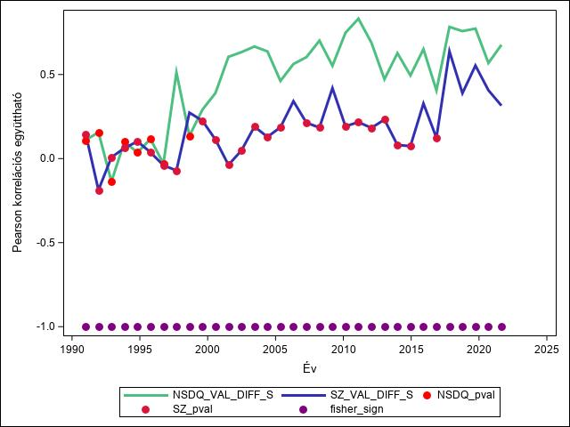
Figure 1. The development of the correlation between the NASDAQ (green) and the Shenzhen Composite Index with the main Taiwanese index (TAIEX). Each data point shows a 50-week projected correlation from the given point in time. The individual values were calculated with a 50-week shift and are only connected for illustration purposes.
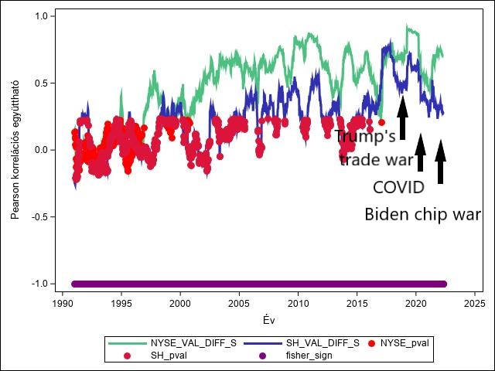
Figure 2. The development of the correlation between the New York Stock Exchange (green) and the Shanghai Composite Index with the main Taiwanese index (TAIEX). Three periods are highlighted: Trump’s trade war, the COVID-pandemic and the decoupling fears (and the Ukrainian war) under Biden Each data point shows a 50-week projected correlation from the given point in time. The individual values were calculated with a 1-week shift and are connected only for illustration purposes.
Figure 1 clearly shows that NASDAQ performs far above the correlation numbers of Shenzhen. While the former has been stably around or above a value of 0.5 since the 2000s, the Chinese counterpart only entered the statistically significant zone towards the end of the examined period – thus somewhat catching up to NASDAQ. If we examine the most recent period, it roughly appears that after Trump initiated his trade war against China (2018), the indicators, which were almost converging, suddenly diverged again. Then, during COVID, after a slight convergence, the outbreak of the Ukrainian war and possibly the strengthening anti-China policy of the Biden administration again increased the difference. The Trump-era trade war and the Biden-era 'decoupling' along with the outbreak of the Ukrainian war are periods that, for the first time in a long time, carried the possibility of some level of American-Chinese economic separation – even the chance of armed conflict over Taiwan. If we consider the New York and Shanghai chart, it is also clear in these two periods (Trump trade war, Biden decoupling) that the Taiwanese stock exchange started moving more closely with the American index again, not the Chinese one, while during the COVID pandemic – which also highlighted the world economy's dependency on Chinese and Taiwanese supply chains – the two correlation values approached each other again. The second figure marks these mentioned periods. These movements and the broader trends seem to fundamentally reinforce the hypotheses formulated.

The Special Role of Hong Kong
During the analyses, the Hong Kong stock exchange went through a unique movement in terms of its correlation with Taiwan. It can be said that in the 1990s, the Hang Seng index showed a clearly stronger co-movement with the Taiwanese stock market than the American indices. There are several reasons for this. Hong Kong only came back under Chinese sovereignty in 1997, so in this period, it cannot be completely called a 'Chinese' stock exchange, yet Taiwanese companies started investing more heavily in China from the early 1990s, and they did this primarily through Hong Kong due to its special status. However, from the 2000s onwards, the American-Taiwanese coefficients either come much closer to the Hong Kong-Taiwanese ones, or the American ones are even stronger. This might be partly due to the fact that from the 2000s, the composition of the Hang Seng gradually changed, and by the middle of the decade, the majority were mainland Chinese companies listed there. In the case of the Hong Kong – American pairs, as seen in the above cases, in the last five years – starting from Trump's trade war – the American indices clearly correlate more strongly with the Taiwanese stock market than the Hong Kong index. If we compare the Hong Kong indicator with the all-American Wilshire 5000, a similar phenomenon can be observed, and here, too, the last five years' separation is clearly visible. The following figure shows 5-year correlation coefficient values for the coefficient lines.
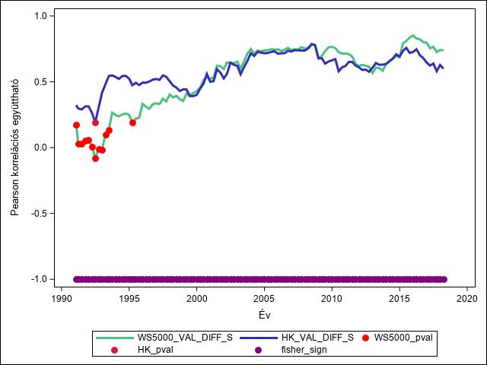
Figure 3. The development of the correlation between the Wilshire 5000 (green) and the Hang Seng (Hong Kong) Composite Index with the main Taiwanese index (TAIEX). Each data point shows a 60-month projected correlation from the given point in time. The individual values were calculated with a 3-month shift and are only connected for illustration purposes.
In the dissertation I showed, that for China I created an indicator that combines – in a capitalization-weighted manner – the Shanghai and Shenzhen stock indices, and one that also adds the Chinese companies listed on the Hong Kong stock exchange to these (HSCEI). I also put the co-movement of these two aggregate Chinese indicators with the Taiwanese index on a chart, along with the co-movement of the American Wilshire 5000 and the TAIEX. The latter includes almost all publicly traded American companies, so we can get an overall Chinese-American comparison with the Taiwanese index. The following figure clearly shows the outstandingly stronger co-movement of the 'all-American' indicator with the Taiwanese stock exchange compared to the 'all-Chinese' indicators.
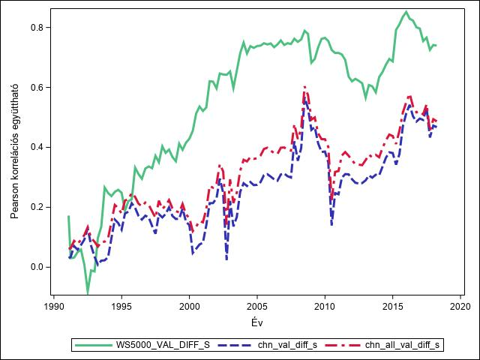
Figure 4. The development of the correlation between the Wilshire 5000 (green) and the individually calculated ’all Chinese' Composite Index with the main Taiwanese index (TAIEX). Each data point shows a 60-month projected correlation from the given point in time. The individual values were calculated with a 3-month shift and are only connected for illustration purposes.

Event Study Analysis

General Introduction
The event study methodology (ESM) was originally developed as a statistical tool for empirical research in accounting and finance (Ball and Brown 1968; Fama et al. 1969). Since then, it has become established in several other disciplines, such as economics, marketing, strategic research, IT, and law (www.eventstudytools.com, n.d.). Eugene Fama, an American economist, is unanimously considered the father of this methodology. According to his Efficient Market Hypothesis (EMH), the price of securities at any moment encompasses the entirety of effects of information available and relevant to them. This is the second fundamental principle of EMH. The theory also assumes that the market operates rationally, where no information is overlooked, there are few or no systematic errors, and thus the market price is in harmony with market fundamentals. (Nguthi, 2013)
Therefore, a stock price reacts more strongly to news that more significantly affects the company's situation/economic performance. The dissertation assumes that if we can successfully distinguish the news categories on which the stock price of the examined economic unit depends (to which it reacts significantly), we can get a picture of the dependency system of the examined economic unit. From these principles, Fama and his colleagues (Lawrence Fisher, Michael C Jensen, and Richard Roll) developed and refined over the decades the event study methodology I use to examine the chosen relations – specifically, a quite new modification of it.

The Specification of the Analysis

Data Collection, Data Preparation
For the examined period, I collected the most important American, Chinese, and Taiwanese economic, financial, security, and domestic political news, and those directly affecting Taiwan, from January 1, 1991 (the opening of the Chinese stock markets) to January 31, 2020 (the Western onset of COVID19), precisely 6016 in number. The selected news was later validated partly with the news from previous Taiwanese studies. The majority of the collected news was in English, with a smaller proportion relying on other sources, primarily Chinese.
The purpose of the news collection was to preliminarily find the dates when any event occurred from the Chinese, American, or Taiwanese side that could have affected the Taiwanese stock market during the examined period. As detailed in the dissertation, for all trading days of the Taiwanese stock exchange in the examined period, I prepared and ran versions of the event analysis model, not only for the days where I initially found potentially relevant news. The pre-collected news and dates could thus be used in two ways. One, to generate different statistics, aggregations for the dates where there was pre-collected news and where there wasn't. The differences read from these also contained information relevant to the dissertation. The other was that I could match the pre-collected news to the set of significant dates (1991-2020) resulting from the event analysis process, and draw interesting conclusions from this pairing. A potential third method of utilization, is the text analytics application – naturally, a further research direction – considering the number and wide spectrum of collected news.
Most of the data preparation tasks were completed during the data preparation for the correlation analysis. Some more steps were needed to create the daily modeling table for the event analysis. The indices transformed into returns and tested for stationarity and normality were already prepared in the correlation modeling table:
- The returns of the Taiwanese stock index (TAIEX) between 1991-2023 – which covered the investigation period of the event analysis (1991-2020).
- The returns of all other American and Chinese stock and aggregate indices that could come into question as benchmark and peer indexes for the models.
The most important task was joining the table containing the events with the table of daily returns used for the correlation analysis. For this, it was necessary to synchronize the dates in the event table according to the return table. As I described in the correlation analysis specification, due to the practically one business day time zone difference between the Far East and the US East Coast stock exchanges, this was done by adding one day to the events in the Far East time zone – taking care to account for weekends and events that otherwise fell on weekends.

Model Specification, Model Versions
To best find the dates within the examined period (1991-2020) when abnormal returns (positive or negative) were realized on the Taiwanese stock market, I used the models selected by the process described in the dissertation's 'Latest Relevant Developments in Methodology' section and aggregate their results as shown in the 'Aggregations and Statistics' section. I used the model transformed from the classic market model by Baker and Gelbach (2020), which is expanded with the so-called 'peer index'. In their referenced study, this is the 2nd model specification (immediately following Fama’s market model):
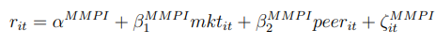
With this model, I estimate the abnormal return for every trading day of the Taiwanese stock market in the examined period. I worked with the following model versions:
- For the observation period, I built 50, 100, and 200 (trading) day models. In the first two versions, I considered the period before the event window, while in the third, I considered the returns of 100 days before and after the event window. This latter version is known as a rolling window event analysis, which provides more robust testing results for both type I and type II errors. (Baker, 2015)
- In terms of the length of the event window, I model for each date (1 day), and beyond that, I also build models for the examined day plus 1 day (2 days) and the examined day plus/minus one day (3 days).
- Regarding the benchmark, as well as the benchmark and peer index, the following model versions were completed:
Benchmark (index models) | Benchmark and Peer models
- SHC (Shanghai)  - NYA (New York)  - Hang Seng (Hong Kong)  - S&P 500 | - Hang Seng and S&P 500  - SHC and NYSE
Then I began mapping the significant dates found. However, to produce the various descriptive statistics, I needed a new level of definition regarding which dates I could really consider significant. At this point, I separated the models completed only with benchmarks and those with both benchmark and peer index. For the former, 4 X 3 X 3, or 36 model versions were created for each trading date, and for the latter, 2 X 3 X 3, or 18 model versions. In both cases, I searched for the optimal threshold above which I could consider a date significant during the experiments, i.e., how many of the 36 benchmark models found a specific date significant.

Results
In the following, I illustrate the results of the event study at different aggregation levels, first for the benchmark models and then for the benchmark+peer index model versions. In this thesis booklet, only a narrow selection of the results is presented.

Benchmark Model Versions
I performed the following aggregations at mild (at least 1 model variation deemed a date significant), moderate (at least 4), and strict (all 9) sensitivity levels. The next three bar charts show the number of dates for the entire examined period that were deemed significant by at least 1, 4, and then 9 model variations respectively for the various benchmark versions indicated:
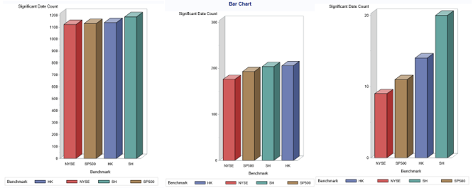
Figure 5. The number of dates showing significant abnormal returns by models built with various benchmark indexes (red: NYSE, brown: S&P 500, blue: Hang Seng, green: Shanghai) at tightening (1, 4, and 9) sensitivity levels.
At the mildest sensitivity level, there is barely a noticeable difference in performance between the model versions indicated by the four benchmarks. The models working with the Shanghai benchmark measured slightly more significant date occurrences between 1991 and 2020, suggesting that the Shanghai index fills the benchmark role somewhat weaker than the other three – meaning it correlates less with the Taiwanese stock index, thus capturing less information, resulting in a higher number of significant news.
At the next presented sensitivity level (second diagram), a date had to be significant in at least 4 variations per model version to be included in the statistics. At this level, not every minor or major fluctuation in the stock market is included in the summaries. Since a date had to show significance in at least 4 model variations, it was ensured that beyond the most permissive 50-day observation window model variations (3), the date had to be found significant in at least one more model variation. We can say that these are days recording more serious stock market movements, presumably triggered by more significant events. The strong performance of the New York Stock Exchange stands out immediately, we can also spot slightly weaker performance of the Chinese benchmarks.
The stricter the sensitivity level for examining the results, the more sharply these 'steps' get distinguishable – and of course, the number of dates found significant generally decreases. At the strictest (9) sensitivity level, it is clear that the models made with the two American benchmark indices measure far fewer significant dates than those made with the two Chinese indices. In general, we can confirm what we experienced during the correlation analysis: the American stock markets correlate more strongly with the Taiwanese index compared to the Chinese ones over the entire period. Particularly noticeable is the strong explanatory power of the New York Stock Exchange, and conversely, the 'weak' performance of the Shanghai index.
In the next step, I also aggregated the model versions by countries, specifically based on which country (United States or China) provided the benchmark index for the model. Thus, I combined the results of the model versions with Hong Kong and Shanghai benchmarks, as well as the New York and S&P 500 benchmark indexes. The following chart shows the results broken down by decades on the sensitivity scale from the mildest to the strictest (minimum 1, 5, 9, 13, 18 respectively):
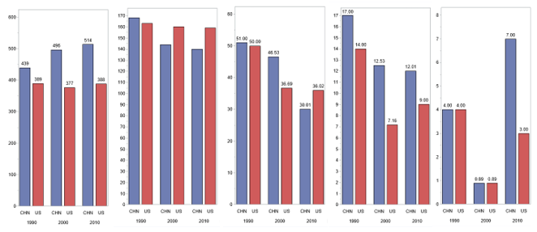
Figure 6. The number of dates showing significant abnormal returns by models built with various benchmark indices at tightening (5, 9, 13, 18) sensitivity levels, aggregated by decades and countries (blue: USA, red: China).
At the mildest sensitivity level, where every date deemed significant by at least one model is included in the statistics, the stronger performance of the American benchmarks is clearly visible (first diagram). At this level, the models working with American benchmarks seem to explain the movements of the Taiwanese stock market quite evenly across decades, showing a similar number of significant dates for all three examined periods, while the Chinese benchmark models report more and more significant events, as if they get less able to function as reliable benchmarks for the Taiwanese stock market. At the next sensitivity level (min 5), the Chinese benchmark models improve, and for the 2000s and 2010s, they follow the Taiwanese stock market more reliably in terms of slightly more significant news than the Americans. However, the difference is not significant, and the American benchmark models can still be said to explain the movements of the Taiwanese stock market evenly across the decades, while the combined explanatory power of the Chinese benchmark models improves over time. If we further tighten the sensitivity, we see that the American benchmark models have stronger explanatory power again in terms of 'really strong' dates. Overall, on the five examined sensitivity levels, only at level 5 do we see the Chinese benchmark models performing stronger, with American dominance visible on all the others. These results fundamentally coincide with those obtained in the correlation analysis, where we saw that the American stock markets moved more strongly in sync with the TAIEX, not the Chinese ones. However, as can be seen above, the extent varies by decade and by sensitivity level.

The Impact of Collected Taiwanese, Chinese, and American News
Next, I examined whether there was any explanatory power discernible among the sources of the pre-collected news (Taiwanese, Chinese, and American). As outlined earlier, I ran a total of 54 models (36 benchmark model variations and 18 peer index-expanded model variations) for every trading day on the Taiwanese stock exchange from early January 1991 to the end of January 2020. I will now scrutinize how the more than 6000 pre-collected but not validated and necessarily subjective Taiwanese, Chinese, and American-origin news are distributed around the dates deemed significant by the above event analysis models. According to my hypothesis (H4), I expect that the American-origin news, falling on dates when the models showed abnormal (either positive or negative) returns on the Taiwanese stock exchange, will outnumber the Chinese ones over the entire period. However, this ratio – according to the hypothesis – will show a realignment in favor of Chinese news towards the end of the period but with lasting American dominance. The presence of Taiwanese news serves to contextualize the actual impact of the two major external influencing forces. Let's therefore see the above analyses projected onto the benchmark+peer models, at various sensitivity levels. First, the tables according to the origin of the news follow, summed up for the entire examined period, at 1, 5, 9, and 14 sensitivity levels:
Table 1. The number of collected news by source (TW: Taiwan, US: USA, CH: China) around dates showing significant abnormal returns on the Taiwanese stock exchange by models including both benchmark and peer indices at various sensitivity levels: from top to bottom and left to right 1, 5, 9, and 14 respectively.
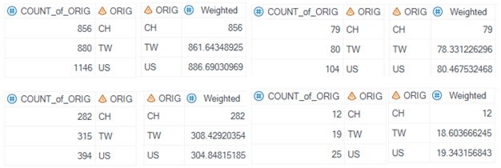
Looking at the weighted numbers, the amount of American and Taiwanese-origin news around the significant events is very similar, with only a nearly 3% American advantage visible at the mildest sensitivity level, but even this can be considered marginal. The number of Chinese-origin news is not far behind proportionally, with the largest percentage difference observed at the 5th and strictest, 14th sensitivity levels, with differences of 7.5% and 38%, respectively. In the latter case we are talking about very low nominal numbers – these are the dates that most models deemed significant.
Also, for the entire period and on the same four sensitivity levels, looking at the involvement of the respective parties (Taiwan, USA, China, not the origin of the news), the numbers of news around the significant dates were as follows (in each table, the three right fields contain the weighted values):
Table 2. The number of collected news by involvement (TW_NEWS: Taiwanese involvement, US_NEWS: American involvement, CH_NEWS: Chinese involvement) around dates showing significant abnormal returns on the Taiwanese stock exchange by models including both benchmark and peer indices at various sensitivity levels: from top to bottom 1, 5, 9, and 14 respectively. On the right side, the values weighted by the number of news are visible.
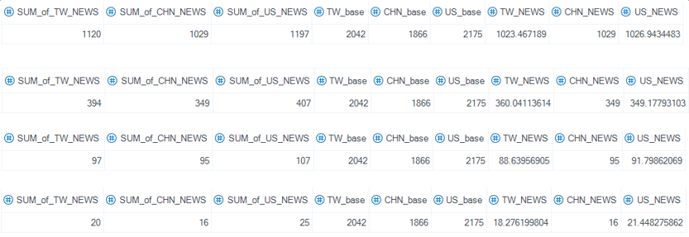 The values for the entire period are very similar. Only around the dates with the strongest impact is there some noticeable American dominance, but these are based on a small number of significant dates anyway. If we look at the numbers broken down by decades (again, only considering the right side, the values weighted by the number of collected news), we see a slight but consistent American advantage in the 1990s across all examined sensitivity levels. The proportional difference is most pronounced in the case of news with the greatest impact, i.e., at the strictest, 14th sensitivity level. Here, approximately twice as many American-collected news were associated with the dates deemed significant by at least 14 model variations, compared to Chinese or Taiwanese news:
Table 3. The number of collected news by involvement (TW_NEWS: Taiwanese involvement, US_NEWS: American involvement, CH_NEWS: Chinese involvement) around dates showing significant abnormal returns on the Taiwanese stock exchange by models including both benchmark and peer indices during the 1990s at various sensitivity levels: from top to bottom 1, 5, 9, and 14 respectively. On the right side, the values weighted by the number of news are visible.
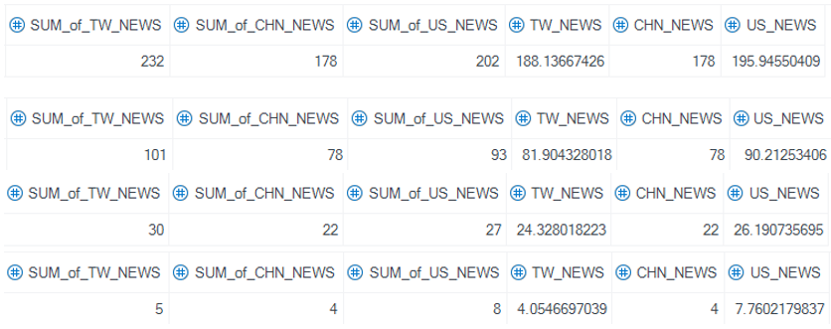
In the 2000s, the trend reverses. The number of American news stories falls to the last place except for the mildest level of sensitivity, while the Chinese news shows a growing - but overall mild - dominance with the increase in sensitivity level:
Table 4. The number of collected news by involvement (TW_NEWS: Taiwanese involvement, US_NEWS: American involvement, CH_NEWS: Chinese involvement) around dates showing significant abnormal returns on the Taiwanese stock exchange by models including both benchmark and peer indices during the 2000s at various sensitivity levels: from top to bottom 1, 5, 9, and 14 respectively. On the right side, the values weighted by the number of news are visible.
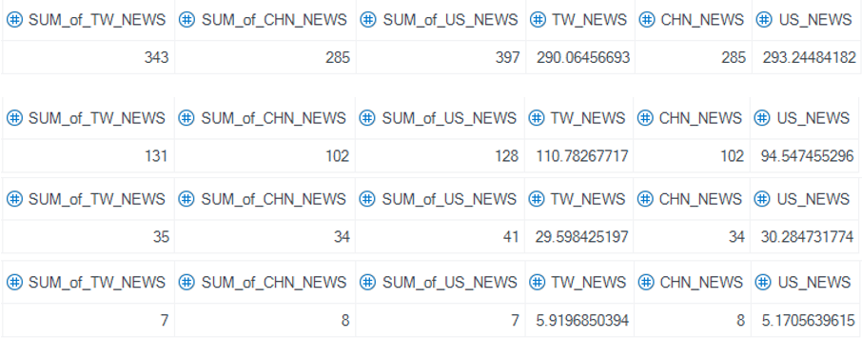
By the 2010s, the picture changes again. The number of Chinese news stories continues to show an initial advantage, but this decreases with the increase in sensitivity level, and in terms of the most significant dates, an American – and Taiwanese – news dominance is again observable against the Chinese:
Table 5. The number of collected news by involvement (TW_NEWS: Taiwanese involvement, US_NEWS: American involvement, CH_NEWS: Chinese involvement) around dates showing significant abnormal returns on the Taiwanese stock exchange by models including both benchmark and peer indices during the 2010s at various sensitivity levels: from top to bottom 1, 5, 9, and 14 respectively. On the right side, the values weighted by the number of news are visible.
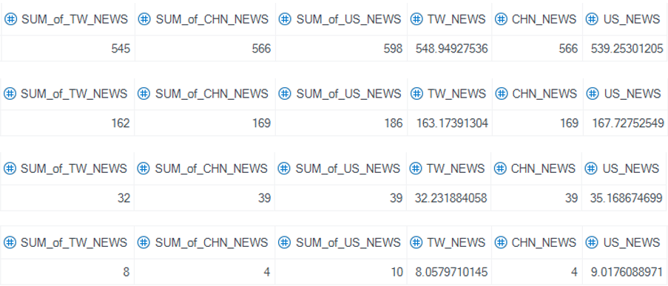
Just as with the benchmark model versions (indtroduced in the dissertation), it is true for the peer indexes models that if we examine at the mildest level of sensitivity, the hypotheses are mostly supported by the results. However, if we increase the levels of sensitivity - thus tightening the definition of what dates are considered to bring significant abnormal returns on the Taiwanese stock exchange - the picture becomes more colorful. When examining decades, looking at the strongest news, the number of Taiwanese and American news moves roughly together with a slight American advantage. In the '90s, it was well above the number of Chinese news, but this ratio reversed in the 2000s - when the most spectacular part of the Chinese economic miracle took place - and returned to the previous pattern by the 2010s.

Conclusion
In the final chapter, I present to what extent the results of my research and analysis support the hypotheses of the dissertation.

First Hypothesis
H1: The Taiwanese economy is vulnerable to the political status quo of the Taiwan Strait, as well as to China in terms of foreign trade, which is reflected in the co-movement of the stock indices of the two sides.
In answering the first research question, I found that the main index of the Taiwanese stock exchange, as well as the indices of the Chinese stock exchanges, show statistically significant co-movement. Based on correlation analyses conducted between 1991 and 2023, the degree of co-movement between Taiwan's TAIEX index and the Chinese stock indices (Shanghai, Shenzhen, Hong Kong) is increasingly significant. The Shanghai and Shenzhen (i.e., mainland Chinese) indices show strengthening correlation with TAIEX over time – especially by the 2010s – with Shanghai's index having a stronger correlation with the Taiwanese index. However, Hong Kong's Hang Seng index correlates much more strongly with TAIEX, although this 'advantage' slightly decreases by the 2010s – due to the stronger correlation of the former two.
In the 1990s, I did not calculate many statistically significant correlation coefficients between the Chinese and Taiwanese stock exchanges – except for the Hong Kong index. During this period, the status quo of the Taiwan Strait underwent significant change, as Taiwan completed its democratization process in the middle of the decade, and fears over Taiwan's declaration of independence intensified in Beijing, culminating in a series of sharp military exercises around the island, as well as the appearance of American aircraft carrier groups. The figures resulting from the dissertation's research work show that during this period, not only the Shanghai but also the Hong Kong stock exchange did not show statistically significant correlation with TAIEX. Although the basic assumption of strong correlation might suggest some level of interdependence, in this case – when the Chinese securities markets were still in their infancy – we might observe the opposite phenomenon. For example, the Taiwanese stock exchange in 1995 either stagnated or moved in a mostly negative range, and it is possible that the unstable political situation of the Taiwan Strait is reflected in these statistically insignificant correlation numbers.
In the 2000s, the correlation between the Chinese stock exchanges and TAIEX generally strengthened. However, this strengthening was not a breakthrough, which could be due to the fact that Taiwan was led by the pro-independence DPP and Chen Shui-bian from 2000 to 2008. By the end of the decade, however, the China-friendly KMT (Kuomintang) and Ma Ying-jeou took over the governance, and the stock market correlation began to really strengthen – except for Hong Kong, as the Hong Kong-Taiwan co-movement had always been strong. The strengthening continued in the 2010s, despite the DPP – and Tsai Ying-wen – coming to power in Taiwan again in 2016. By this time, Chinese stock markets also got more established, and economic interdependencies presumably overrode political fears – and after two terms of DPP governance, it was likely that the new cabinets would not put the issue of secession on the agenda either.
In the 2020s, an interesting phenomenon seems to be emerging: the correlation numbers of the Hang Seng index with Taiwan have started to 'align' with those of the two Chinese counterparts, which in this case means a strong decline. This may be partly due to the political changes in Hong Kong from the mid-2010s, i.e., the significant erosion of Hong Kong's limited political independence, and partly to the fact that from the 2010s, the defining companies of the Hong Kong stock exchange were already mainland Chinese companies. When fears of 'decoupling' intensified, the change in the Hong Kong stock exchange's co-movement with Taiwan followed a similar – negative – trajectory to the other two Chinese exchanges.
Looking at the entire period examined, it can be said that the Chinese and Taiwanese indices are moving together more strongly, which may be an indicator of the interconnection of the two economies. This may result from the strengthening of general global interdependencies over the period, and generally from the strengthening of stock market convergence, but this increasing degree of co-movement may also be an indicator of Taiwan's exposure to China. The correlation – and news collection – results do not allow for further conclusions to be drawn.

Second Hypothesis
H2: The Taiwanese economy is largely vulnerable to the flows of the global economy led by the United States, mainly through the mediation of the Chinese economy, at least as much as indirectly to the Sino-Taiwanese political situation, which is also detectable in the development of stock indices. Therefore, according to the hypothesis, the Taiwanese stock index follows the movement of the American indices at least as strongly as the Chinese ones.
It would be difficult to prove the part of the hypothesis that the Taiwanese economy is indirectly dependent on the American economy through the Chinese economy solely based on stock market co-movements, but the results undoubtedly strengthen this assumption. The examined American stock exchanges consistently show very strong correlation values with the Taiwanese stock exchange, stronger than their Chinese counterparts except for the '90s due to Hong Kong. The 2000s brought a stable, predictable increase, from then on maintaining a minimum 0.5 correlation coefficient between American and Taiwanese stock returns. Although there were two more significant declines in the 2010s in terms of the correlation coefficient, overall, it can be said that the American-Taiwanese stock correlation numbers, similar to the Chinese-Taiwanese relationship, show a generally strengthening trend. Since they started from higher values than the former, this strengthening is less noticeable. This phenomenon - as in the case of the Chinese-Taiwanese relationship, also in the case of the American-Taiwanese stock correlation - can be explained by the generally strengthening global stock market and economic convergence, the deepening of global economic interdependencies, and also that Taiwan's economic exposure to the United States has further strengthened. More on this, and the comparison of Chinese-American effects, will be written in the next hypothesis and the third research question in the dissertation.

Third Hypothesis
H3: The integration between the Taiwanese and American indices, although decreasing over a 30-year period, is still stronger than the integration between the Taiwanese and Chinese indices.
My research results support this hypothesis the strongest among the four. The American indices correlate more strongly with the Taiwanese stock exchange than the Chinese ones for the entire examined period (1991-2023), this is most noticeable in the case of the ’all Chinese' and 'all American' indicators. The hypothesis also mostly holds that this difference is disappearing over time. However, the results do not perfectly reflect the preliminary expectations.
In the '90s, none of the examined stock exchanges correlated too strongly with the Taiwanese stock exchange, except for Hong Kong. Until 1997, Hong Kong was under British sovereignty, and during this decade, only a small number of mainland Chinese companies were listed on the Hong Kong stock exchange, so it's questionable whether we can consider Hong Kong as a full-fledged 'Chinese' stock exchange at that time. Nonetheless, it's a fact that during this period, the Hang Seng correlated more strongly with TAIEX than the American stock exchanges - although this correlation was not too strong either. Overall, this was a quite exciting and therefore volatile period. The stronger Hong Kong correlation is probably also due to the start of Taiwanese investments in China via Hong Kong. Until 2008, there were no (non-charter) flights directly between Taiwan and China, and business travel also took place via Hong Kong.
Another interesting, episodic observation from the '90s is that analyzing the correlation results, a significant 'collapse' in correlation with the Taiwanese stock exchange was observed in the mid-'90s, regardless of whether the examined stock index was American or Chinese. The Taiwanese stock exchange performed weakly then (especially in 1995), probably because the island finally transformed into a democracy at that time, and there was the so-called third Taiwan Strait Crisis, during which China practiced with live ammunition around the island several times, and the United States also sent aircraft carrier groups to the Taiwan Strait. Then, after the first fully democratic elections, the situation on the Taiwanese stock exchange gradually 'normalized'. Although this 'correlation collapse' with the Taiwanese stock exchange was observable in all relations (Chinese, American indices alike) during this period, contrary to the hypotheses, it may be that the collapse of the correlation coefficients during this dangerous period for Taiwan is what really indicates how vulnerable Taiwan is to the Chinese and American sides, especially if they are also in conflict over Taiwan.
The 2000s and 2010s brought the pattern formulated in the hypothesis: the Taiwanese index correlated more strongly with the American indices, but this difference showed a decreasing trend over time. It's noteworthy that during this period, the NYSE generally moved more in line with the Taiwanese stock exchange than the Hong Kong one - which had become dominated by mainland Chinese companies by the second half of the 2000s.
For the 2020s, it's difficult to establish trends as of the writing of the dissertation (spring of 2023), but an interesting phenomenon seems to be unfolding. The results roughly show that after Trump launched his trade war against China (2018), the then-converging Chinese-Taiwanese and American-Taiwanese correlation indicators suddenly diverged again, then after another mild convergence during COVID-pandemic, they diverged again with the outbreak of the Ukrainian war and the Biden administration's strengthening anti-China policy. These movements seem to fundamentally strengthen the assertions in the hypotheses. According to the third hypothesis, the Taiwanese economy is still more dependent on the American one than the Chinese one, although this difference is fading. If my observation is correct, then in the case of a crisis that could result in a possible American-Chinese economic divergence, Taiwan seems to tend to lean more towards the former. The Trump-era trade war and Biden-era 'decoupling' along with the outbreak of the Ukrainian war are periods that, for the first time in a long time, carried and still carry the possibility of an American-Chinese economic divergence - and even the possibility of armed conflict over Taiwan. During these two periods, it is noticeable that the Taiwanese stock exchange again started to move more in line with the American index, not the Chinese one, while the two correlation values approached each other again during the intervening COVID-pandemic.
Finally, it's worth mentioning a few words about the relevant results of event analyses. The models in which I used one or another of the Chinese or American stock exchanges as a so-called benchmark index also showed that the American stock exchanges have a stronger explanatory power regarding the returns of the Taiwanese stock exchange. Even at the - according to the terminology of this dissertation - mildest level of sensitivity, it was observable that the models working with the Shanghai benchmark measured slightly more significant date occurrences between 1991 and 2020. From this, I concluded that the Shanghai index fills the role of a benchmark slightly weaker than the other three - meaning it correlates less with the Taiwanese stock index, thus capturing less information, resulting in a larger number of significant news. As I increased the sensitivity level - thus tightening the definition of dates bringing abnormal returns on the Taiwanese stock exchange - this difference between the performance of the American and Chinese benchmarks strengthened in favor of the former. Generally, the results of event analyses also confirm what was experienced in the correlation analysis: the American stock exchanges correlate more strongly with the Taiwanese index than the Chinese ones do for the entire period. The strong explanatory power of the New York Stock Exchange is particularly noticeable, as opposed to the 'weak' performance of the Shanghai one.

Fourth Hypothesis
H4: The Taiwanese stock market reacts more sensitively to American news than to Chinese news, but this difference becomes less significant over time (over a 30-year interval).
Examining the results of the benchmark models weighted by the number of collected news at the mildest level of sensitivity, it can be said that in the '90s and 2000s, American news were slightly more prevalent than both Taiwanese and Chinese news around significant dates. However, this advantage showed a slight decrease from the '90s to the 2000s. In percentage terms, this means that while in the '90s there were about 4.6% more American news measured than Taiwanese and nearly 6% more American than Chinese, by the 2000s these ratios decreased to 4.3% and 5.2%, respectively. Although this is a relatively insignificant change, by the 2010s, Chinese news were in relative - but not absolute - majority, about 4.5% more than Taiwanese news and 8.1% more than American news. Although these proportional differences are not large to begin with, the differences themselves, as well as the trend of change in differences, coincide with the original hypothesis (H4).
It is noteworthy that although Taiwanese news were consistently in second place, they were never first in any decade, which could indicate that both American and Chinese news had a significant impact on the Taiwanese stock market. In addition, the process of 'changing of the guard' is also noteworthy, as by the 2010s I found more Chinese than American pre-collected news around the dates identified as significant by the models. This trend is consistent with the fourth hypothesis, which, however, still assumed American dominance for the 2010s. However, it is important to note the performance of the benchmark indices, where the American indices clearly showed a significant performance advantage by the 2010s. Therefore, the seemingly stronger influence of Chinese news on the Taiwanese stock market may be partly due to the fact that the American benchmarks 'captured' the impact of American events much better during this period. The strong performance of the American benchmark indices was also foreshadowed by the results of the correlation analysis. Without this, it's likely that proportionally many more significant American news could be observed in the 2010s as well.
The picture changed somewhat with the tightening of sensitivity levels - see the answer to the sixth research question in the dissertation. However, at the strictest level of sensitivity, where I examined the most impactful news, the dominance of American news was again noticeable - even in the 2010s. Therefore, the results of the event analysis partially support the hypothesis, but they do not provide sufficient evidence. To support my hypothesis with greater certainty, it is necessary to perform news validation for further answers, meaning that for each date bringing significant abnormal returns, the news that had the strongest impact on the daily rate according to the stock market almanacs needs to be found and categorized. These results are then worth further analyzing and interpreting together with the results of the correlation analysis.
At the current level of event analysis, if we interpret the results of the mildest sensitivity level together with the results of the correlation analysis, the picture formulated by the hypotheses clearly emerges: the American stock market and news have a greater impact on the Taiwanese stock market than the Chinese ones. This is more strongly supported by the results of the correlation analysis and with strong limitations by the results of the event analysis. This conclusion - the American dominance - seems to still stand at the time of writing the dissertation, but the difference is fading.

Reference List
Baker, A.C. (2015). Single-Firm Event Studies, Securities Fraud, and Financial Crisis - Problems of Inference. [online] Social Science Research Network. Available at: https://papers.ssrn.com/sol3/papers.cfm?abstract_id=2674495 [Accessed: 27th November 2023.].
Baker, A.C. and Gelbach, J.B. (2020). Machine Learning and Predicted Returns for Event Studies in Securities Litigation Preliminary and Incomplete. SSRN Electronic Journal. doi:https://doi.org/10.2139/ssrn.3600432 [Accessed: 27th November 2023.].
Ball, R. and Brown, P. (1968). An Empirical Evaluation of Accounting Income Numbers. Journal of Accounting Research, 6(2), pp.159–178.
Brownlee, J. (2019). How to Choose a Feature Selection Method For Machine Learning. [online] Machine Learning Mastery. Available at: https://machinelearningmastery.com/feature-selection-with-real-and-categorical-data/ [Accessed: 27th November 2023.].
Corporate Finance Institute. (n.d.). Exponentially Weighted Moving Average (EWMA). [online] Available at: https://corporatefinanceinstitute.com/resources/capital-markets/exponentially-weighted-moving-average-ewma/ [Accessed: 27th November 2023.].
Dale, M.R.T. and Fortin, M.-J. (2009). Spatial Autocorrelation and Statistical Tests: Some Solutions. Journal of Agricultural, Biological, and Environmental Statistics, [online] 14(2), pp.188–206. Available at: https://www.jstor.org/stable/20696567 [Accessed: 27th November 2023.].
Fama, E.F., Fisher, L., Jensen, M.C. and Roll, R. (1969). The Adjustment of Stock Prices to New Information. International Economic Review, 10(1), pp.1–21.
Gelbach, J.B., Helland, E. and Klick, J. (2013). Valid Inference in Single-Firm, Single-Event Studies. American Law and Economics Review, 15(2), pp.495–541. doi:https://doi.org/10.1093/aler/aht009 [Accessed: 27th November 2023.].
Kastner, S.L. (2009). Political Conflict and Economic Interdependence Across the Taiwan Strait and Beyond. [online] Stanford University Press. Stanford: Stanford University Press. Available at: https://www.sup.org/books/title/?id=16474 [Accessed: 27th November 2023.].
Mainland Affairs Council, R. of C. (Taiwan) (2019). Mainland Affairs Council, Republic of China (Taiwan). [online] Mainland Affairs Council, Republic of China (Taiwan). Available at: https://www.mac.gov.tw/en/News_Content.aspx?n=69EE7CEA8C7550BB&sms=D6D0A9E658098CA2&s=FD1ADAC687DF1AC0 [Accessed: 27th November 2023.].
Ministry of Foreign Affairs (2019). History of Taiwan. Government Portal of Republic of China, Taiwan, [online] 1. doi:https://doi.org/A03000000B [Accessed: 27th November 2023.].
Nature. Proportion of Taiwan’s exports income to China, Japan, South Korea, Singapore, Malaysia, Indonesia, Thailand, and the United States from 2001 to 2021. | Humanities and Social Sciences Communications. (n.d.). www.nature.com. [online] Available at: https://www.nature.com/articles/s41599-023-01903-8/figures/1 [Accessed: 27th November 2023.].
Nguthi, P.N. (2013). The Effect of Political News on Stock Market Returns in Kenya: the Case of March 2013 General Elections. [online] erepository.uonbi.ac.ke. Available at: http://erepository.uonbi.ac.ke/handle/11295/58915 [Accessed: 27th November 2023.].
Nikkinen, J., Omran, M., Sahlström, P. and Äijö, J. (2006). Global stock market reactions to scheduled U.S. macroeconomic news announcements. Global Finance Journal, 17(1), pp.92–104. doi:https://doi.org/10.1016/j.gfj.2006.06.003 [Accessed: 27th November 2023.].
Pineda, M.E. (2023). Major Suppliers of Apple: Inside Its Supply Chain. [online] Profolus. Available at: https://www.profolus.com/topics/major-suppliers-of-apple-inside-its-supply-chain/.
Statista. (2023.). Apple sales share by country/region 2012-2023. [online] Available at: https://www.statista.com/statistics/382288/geographical-region-share-of-revenue-of-apple/?locale=en [Accessed: 27th November 2023.].
www.eventstudytools.com. (n.d.). Overview of Research Applications | EST. [online] Available at: https://www.eventstudytools.com/research-using-event-studies [Accessed: 27th November 2023.].
www.tpex.org.tw. (2023). Taipei Exchange > About TPEx > History. [online] Available at: https://www.tpex.org.tw/web/about/introduction/history.php?l=en-us [Accessed: 27th November 2023.].
www.twse.com.tw. (2023). TAIEX Total Index Historical Data - Taiwan Stock Exchange Corporation. [online] Available at: https://www.twse.com.tw/en/page/trading/indices/MI_5MINS_HIST.html [Accessed: 27th November 2023.].
Yuan, N., Xoplaki, E., Zhu, C. and Luterbacher, J. (2016). A novel way to detect correlations on multi-time scales, with temporal evolution and for multi-variables. Scientific Reports, 6(1). doi:https://doi.org/10.1038/srep27707 [Accessed: 27th November 2023.].

List of Related Publications
A Contextual Historic Background for Cross-Strait Relations Studies In: Beke Lisányi, Judit; Vándor, János (ed.): The Current Issues of Economic and Social Integration in Hungary and Taiwan. Budapest Business School. Budapest. 2016. ISBN 978-915-5607-71-2.
Döntőbe jutott: Trump, Xi. Felkészül: Tajvan – A Tajvan–USA–Kína háromszög a Trump-elnökség elején. [Getting around the Taiwan Issue – The Taiwan–USA–China Triangle at the beginning of the Trump Presidency]. Working paper for the Pázmány Péter Catholic University Faculty of Humanities and Social Sciences, Pázmány East Asia Club, Hungary (PEACH). 2017. Available at:
https://btk.ppke.hu/storage/tinymce/uploads/old/uploads/articles/1690590/file/peach_mt_13_szentesi_trump_xi_tajvan.pdf.
Review: Scott L. Kastner’s Political Conflict and Economic Interdependence across the Taiwan-Strait and Beyond. (Magyar.) Budapest Business School, Prosperitas learned journal. 2016.
Taiwan-China: A New Era on the Rise. In: Miracles do Happen: Taiwan’s Economic Development. Edited by Dean Karalekas and Csaba Moldicz. Budapest Business School, Chiang Ching-kuo Foundation. 2016. ISBN: 978-615-5607-24-0.
The Main Contexts in Cross Taiwan Strait Relations. In: IMBusiness International Management and Business – Academic Journal of the Budapest Business School. Vol 1, N 2. Pp. 45-96. Budapest. December, 2016. HU ISSN 2498-7174.

Between the CCP and the KMT, frozen in 1949.
The term ’taishang’ refers to the colony of Taiwanese businessmen who have settled in mainland China to do business.
Throughout the dissertation, I often use the term 'American', which always refers to theUnited States of America.
Due to the development of the global chip shortage and Taiwan's unique position in the global chip manufacturing supply chain, it is legitimate to consider that China and the USA are also dependent on Taiwan. However, this thesis does not discuss this direction.
Of course, we cannot consider the securities markets as complete embodiments of a national economy. However, they may serve as proxies for their indicators if the composition of the index is considered sufficiently diversified, and the market capitalization measures up to the country's annual GDP. These conditions are met for the selected indices.
I only utilize a separate sub-index of Hong Kong's stock exchange for companies that are registered on the Chinese mainland but listed on the Hang Seng (HSCEI).
I performed all data preparation and data analysis operations using SAS Enterprise Guide.
Which generally heightened fears of the Chinese-American conflict over Taiwan.
The third hypothesis suggests that the Taiwanese economy still depends more on the United States than on China, although this difference is diminishing. If my above observation is true, then in the case of a crisis that could lead to a possible economic separation between the United States and China, Taiwan would probably lean more towards the former.
I provide a detailed account of the methodology, its history, ramifications, and recent developments in the dissertation. In this thesis booklet, I do not delve into these aspects in detail.
I collected the news partly through my previous research and publications and partly through new research work, but in all cases, manually, typically using Google. All the saved news articles are attached in a separate Excel file to the dissertation.
The latter was less important in this case due to the advantageous features of SQ testing.
Although I gathered many events that spanned multiple days, analyzing them separately would have required disproportionately extensive preparatory work, so this is not part of the analysis.
For significance testing, I used the two-tailed SQ test developed by Gelbach (2013) at a 0.05 confidence level – meaning at a 0.025 level on each side.
When I set this threshold at 7, I only proceeded with the dates that were found significant in at least 7/36 model versions. I explain this in more detail in the Results of Event Analysis section of the dissertation.
Illustrating with an example, at the 18th sensitivity level, the 'US' (United States aggregate) significant dates can include those dates that were deemed significant according to both model versions (New York and S&P 500 benchmark indexes versions) and their 9-9 model variations, meaning a total of 18 American benchmark index models considered them significant out of the 18 possible.
I elaborate on this further in my response to the third research question in the dissertation.
This is a custom-made index that includes Chinese companies listed on the Shanghai, Shenzhen, and Hong Kong stock exchanges.
The Wilshire 5000.
It rarely exceeded a correlation coefficient value of 0.5.
Possibility is, of course, just the possibility. It might be significantly higher than before, still rather low.

